- Go to www.indianavoters.in.gov
- Click on the blue box that says “Check Voting Status”
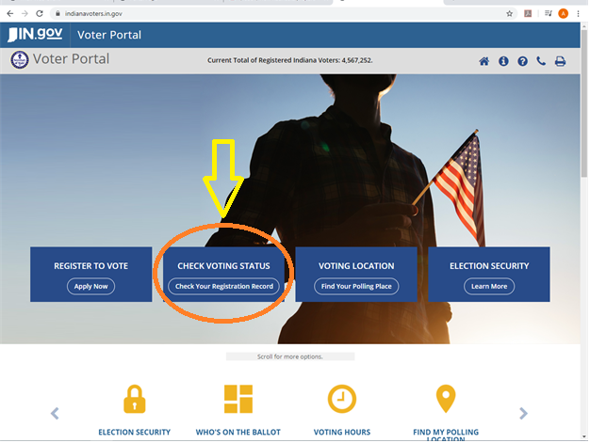

- A box will pop up asking for your name, date of birth, and county. Enter this information and click “Submit”

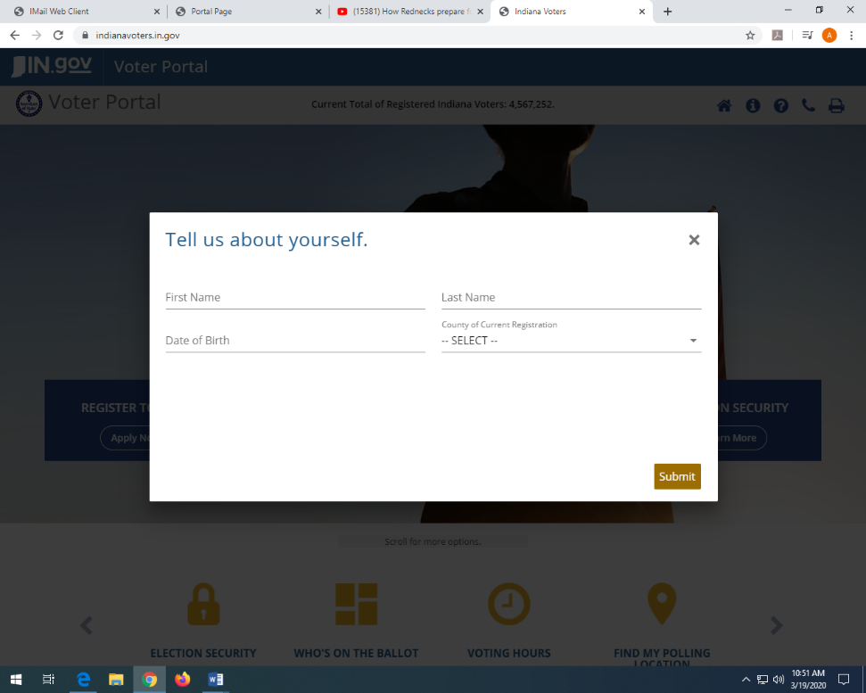

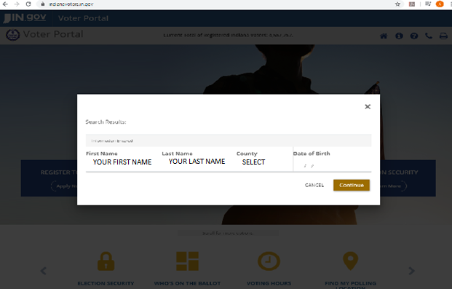
- Another box will pop up with the results found. Enter your information and click “Continue”

- You are now on a page with all of your Voter Registration Information.
- Make sure your registration information is correct and that your status is Active.
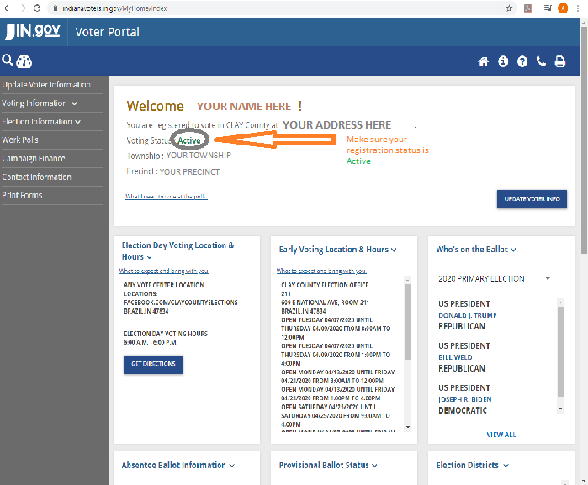

If all of your information is correct and your registration is Active, you DO NOT need to register again.
If you need to update your registration, do this:
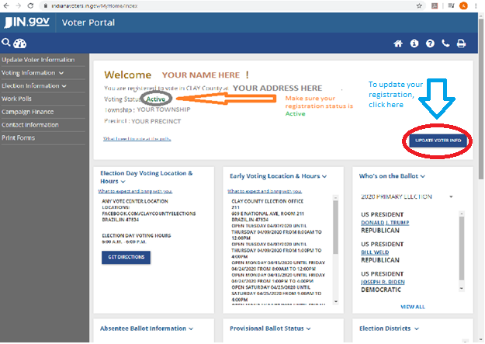
- Click the box on the right that says “Update Voter Info”

- Enter your driver’s license number and click “Submit”
- Enter the correct information and click “Continue”

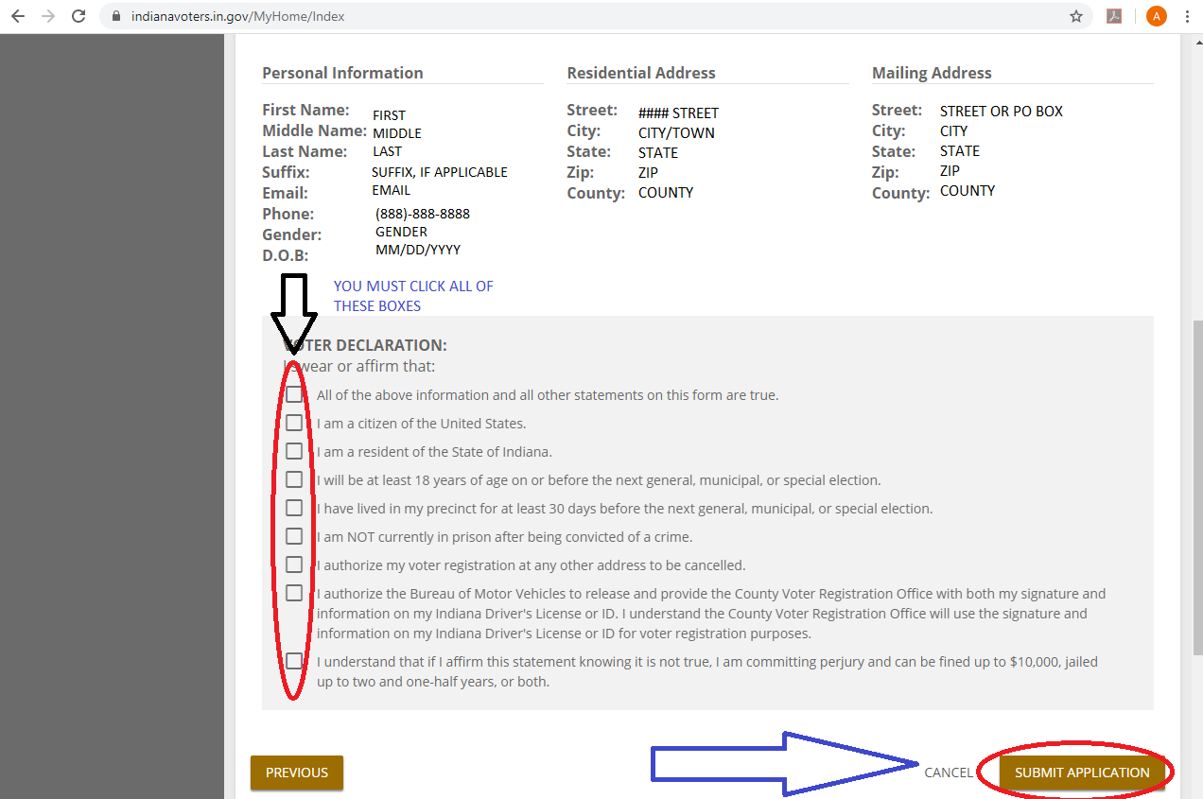
- Review your information on the next page and click all of the boxes on the left side to complete your voter affirmations. Click “Submit Application”

On the Voter Registration Information page, you can see early voting hours, who is on the ballot, and apply for an Absentee Ballot.
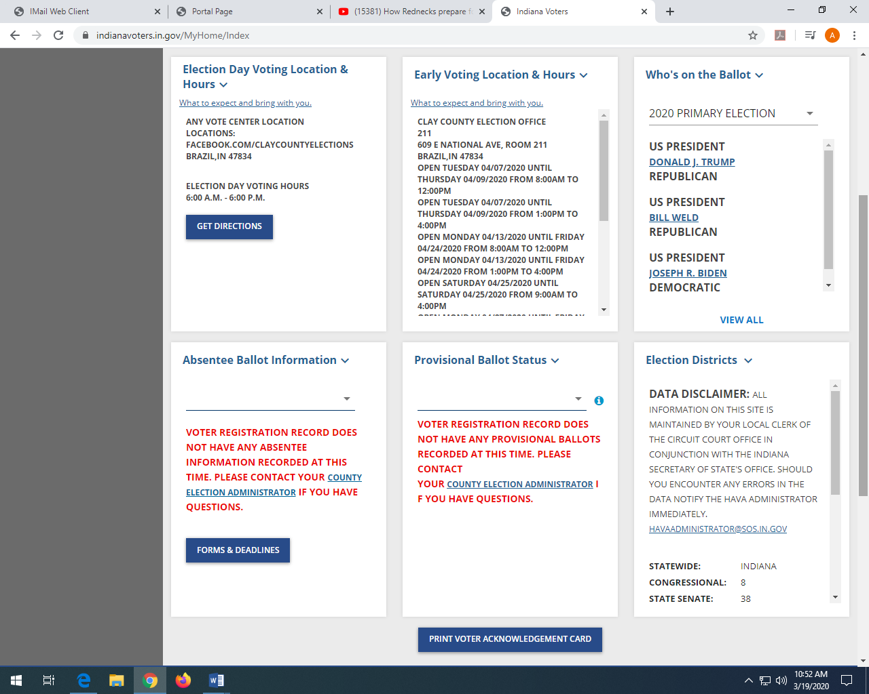

To apply for an Absentee Ballot:
- In the Absentee Ballot Information box, click “Forms & Deadlines”
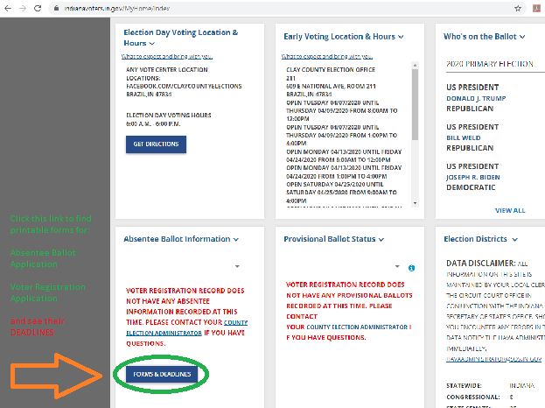

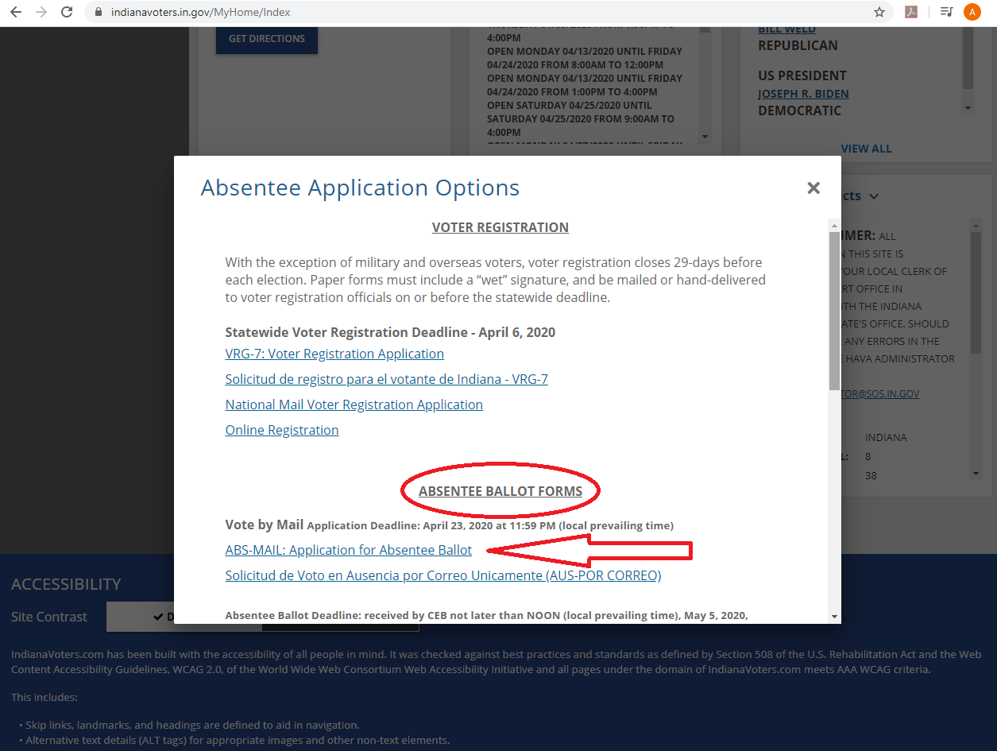
- A box will pop up with Absentee Application Options. Scroll down to the Absentee Ballot Forms section.

- Select ABS-MAIL: Application for Absentee Ballot
- This will cause a .pdf form to download.
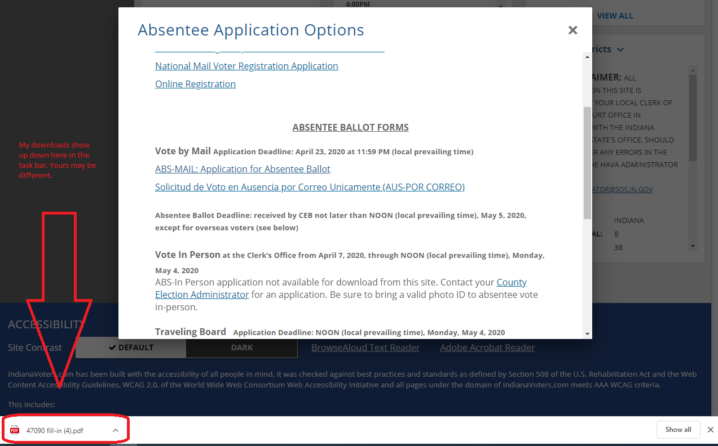
- Open the downloaded form.
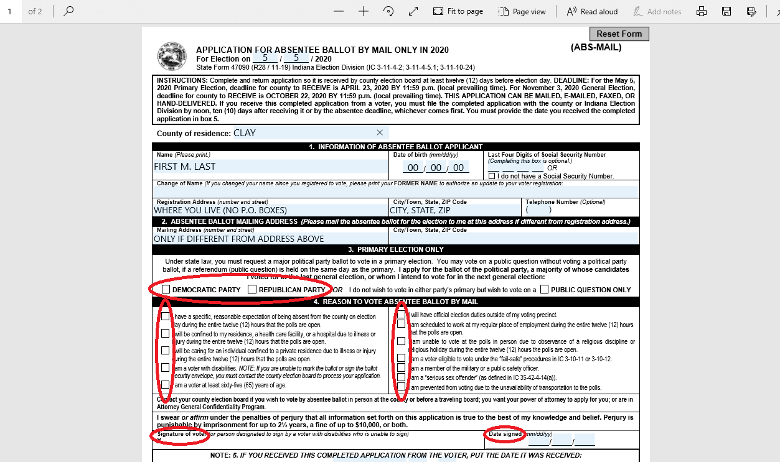
- Fill out the form and be sure to sign and date it.
- Mail this form to: Clay County Election Office, 609 E National Ave, Room 211, Brazil, IN 47834
- We must receive this application by noon on Thursday, April 23, to send you a ballot.

